Intracept Chart

User Manual

Intracept for Windows

Data Acquisition for the
Laboratory from
Intracel

Copyright © Intracel & University of Strathclyde 1996-2001

Neither the whole nor any part of the information contained in, or the product described in, this manual may be adapted or reproduced in any material form except with the prior written approval of Intracel.

Published by

Intracel
Unit 4
Station Road
Shepreth
Royston
Herts.
SG8 6PZ
England

Tel: 01763 262680
Fax: 01763 262676

Email: intracel@cosmark.cityscape.co.uk

Trademarks and Tradenames used in this guide are acknowledged to be the trademarks and tradenames of their respective Companies and Corporations.

Contents

Starting Chart 4
Making a recording (Quick Guide) 4
Creating a new data file 5
Opening data files that already exist 5
Setting up for a recording 6
Using the calibration wizard 7
Displaying signal records 8
Changing the display vertical magnification 8
Making signal measurements 9
Zero levels 9
Printing signal records 10
Choosing and setting up printers 10
Using the stimulus generator 11
Setting up the stimulator 11
Using the stimulator 11
Computing heart rate from an electrocardiogram 12
Using the electromyogram RMS function 13
Using a CED 1902 amplifier 14

Starting Chart

Click the Windows Start button and select

Programs
Intracept
Chart

to start the Chart program shown below.

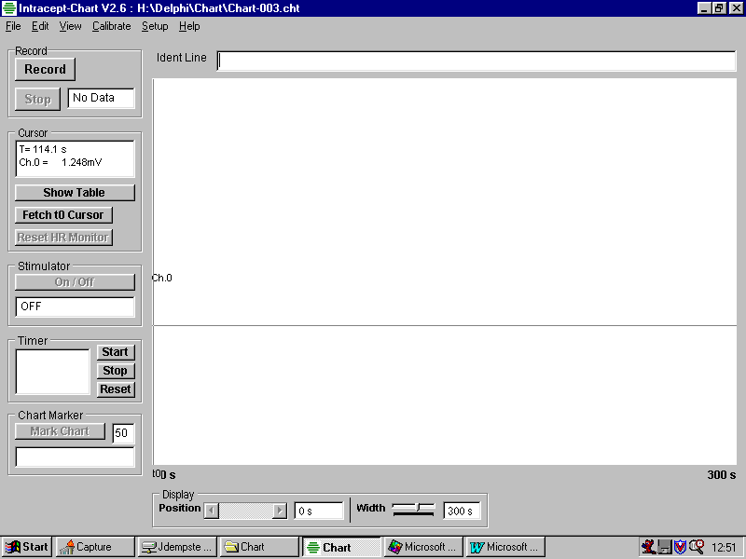

Making a recording (Quick Guide)

The basic procedure for making a recording is as follows.

1) Open a new data file to hold your recording session, by selecting New data file..from the File.. menu. (Note. If you want to append data to the end of an existing file, using the Open data file.. command.)

2) If you need to change the number of input channels being recorded, sampling rate or other recording settings, select Recording... from the Setup menu.

3) Select a suitable size for the display window, using the Display Width slider bar.

4) Click on the Record button to begin recording signals.

5) Click on the Stop button to stop recording.

Creating a new data file

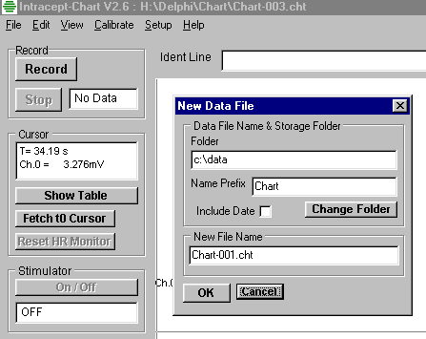
To create a new data file select New data file.. from the File menu to open the data file creation dialog box.

Chart automatically generates sequentially numbered data file names (Chart-001.cht, Chart-002.cht …) which are stored by default in the folder “c:\intracept”

To change the data file prefix (initially set to “Chart”), enter a new prefix in the Name Prefix box.

If you want to include the date in the file name tick the Include date check box.

To change the data file storage folder click the Change Folder button, and select a new disc drive and folder from the list presented.

To create the new data file, click the OK button.

Opening data files that already exist

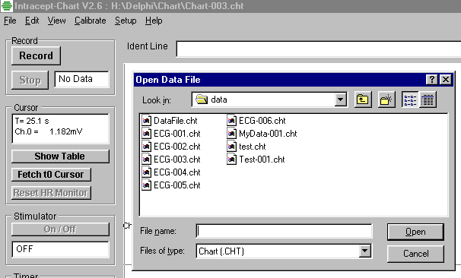
To open an existing data file select Open data file.. from the File menu to open the data file selection dialog box.

Select the desired file from the list of names presented in the dialog box.

If your file is not in the default data folder, you can select another folder or disc drive using the Drives and Directories list boxes.

When you have selected a file click the OK button to open it.

Setting up for a recording

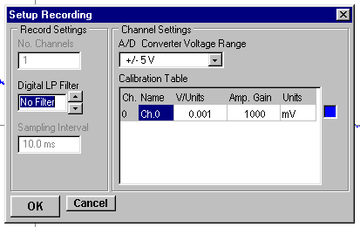
Select Recording.. from the Setup menu to display the recording setup dialog box, used to set the number of input channels, channel scaling factors and units, and sampling rate.

No. Channels Sets the number of input channels to be recorded. (Max.=4). [NOTE. The number of channels can only be changed when the data file is empty.]

Sampling Interval Sets the time interval (msecs) between samples for each channel (Min.=1.0xNo. channels msecs.) The sampling interval should be chosen to ensure that there are a sufficient sampling rate to allow accurate measurement of the fastest changing part of the signals being studied. . (A sampling interval of 10 msec is usually sufficient for most purposes)

A/D Converter Voltage Range Sets the input voltage range of the A/D converter used to make the measurements of the analogue signals. (Ranging over a 100-fold, from ±5V to ±50mV.) This setting applies to ALL channels.

Digital LP Filter Chart has a low pass digital filter algorithm which can be used to smooth the the stored recordings. The cut-off frequency (Hz) can be set using this entry. The lower the cut-off frequency the greater the smoothing.

Channel Settings Table

The channel settings table indicates the analogue channel numbers which are in use and defines the names, units, amplification and scaling factors for each channel.

Ch. The Intracept TSI1 I/O box channel number (0, 1, 2, 3.).

Name The channel name displayed along side each trace on the screen and on hard copies. Names can be up to 4 letters.

V / Units The channel calibration factor (Volts per Unit) which scales the signal from volts to the units defined below (Units)

Amp. Gain The gain factor for any amplifier (e.g. Intracel TSA1 or CED 1902) that might be used to amplify the transducer signal before it is digitised.

Units The physical units of the signal being measured by the transducer. (E.g. in the case of muscle tension units might be grams). The units names can have up to 4 letters.

Colours The colour of each Chart trace can be set by clicking on the channel’s colour box and selecting a colour.

Using the calibration wizard

Chart’s calibration wizard is designed to simplify the process of calibrating an input channel to read out in terms of the measurement units defined for the channel, using a calibration signal of known amplitude. Calibration is a four step process for each channel within the signal record. Each stage is guided by instructions from the “wizard”.

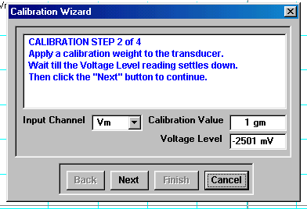
To calibrate a channel, select Calibrate to open the Calibration Wizard.

- Select the channel to be calibrated by selecting one from the Input Channel list box. (If there is only one channel this stage is omitted). Then click the Next button to go to the next stage. Note that you can go back to repeat a previous stage using the Back button.)

- Apply the calibration signal to the input of the selected channel. (The nature of this signal depends on the transducer attached to the channel. A typical example is a 1 gram weight attached to a tension transducer). Once the signal has settle down (as indicated by the Voltage Level display) click the Next button to continue.

- Remove the calibration signal. Wait till the signal settles down. Then click the Next button. (This stage is used to determine the signal zero level.)

- Enter the magnitude of the calibration signal into the Calibration Value box. Then click Finish.

This process should be repeated for each channel that needs to be calibrated.

Displaying signal records
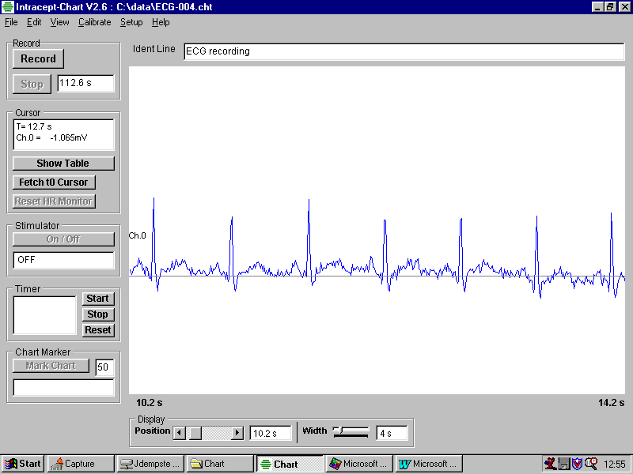
When Chart is not recording you can view the signals stored in the data file using the Display controls. By changing the duration of the display window you can obtain either a compressed view of the whole recording in the file or magnify a small section.

The width (period of time displayed) of the display window can be adjusted using either the Width slider bar or by directly entering the window duration in the Width box and pressing the <return> key.
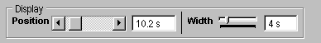
The location of the display window within the recording can be set using the Position scroll bar.

Changing the display vertical magnification
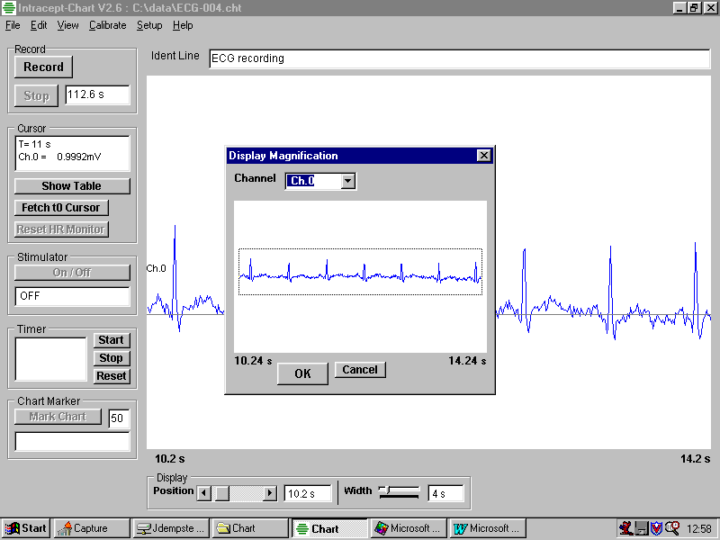
The upper and lower limits of the displayed region of each channel can also be changed allowing the signal to be expanded vertically to fill the display area.

To change the display region for a channel.

- Double click the left mouse button over the channel to be changed, to pop up the Display Magnification dialog box.

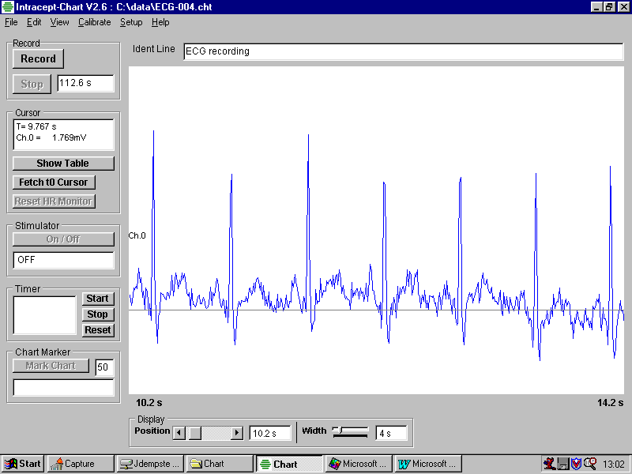
- The display region in current use for that channel is indicated by a grey box superimposed on the signal trace. To change the display region, click on the top or bottom edges of the box and drag it to a new position while hold down the left mouse button.

- When this is done click OK.

Note. To quickly restore the vertical display magnification settings for all channels to minimum, select Zoom Out from the View menu.

Making signal measurements

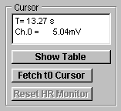
When the mouse is moved over the display window it turns into a measurement cross-hair and the calibrated signal level at that point appears in the Cursor readout box.

Series of measurements can be accumulated in Chart’s measurements table and then transferred to other programs via the Windows clipboard. A measurement can be saved to the table by clicking the Add to Table button.
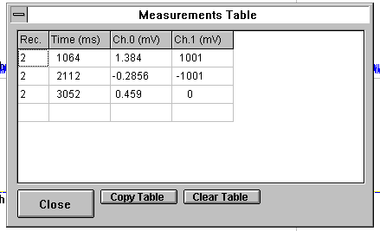
The contents of the measurements table can be displayed by clicking Show Table.

Clicking the Copy Table button copies the measurements to the Windows clipboard. The table can be cleared of data by clicking the Clear Table button.

Zero levels
Amplitude measurements are made relative to preset zero levels for each channel in the record. These are indicated by horizontal grey lines. To change the position of these levels.

- Move the mouse cursor over them until the icon changes to Up/Down arrows.
- Press and hold down the left mouse button.
- Then drag the cursor up or down.

Time measurements are made relative to a zero time cursor, indicated by a vertical grey cursor with the letters “t0” at the bottom. This cursor is initially set at the start of the recording. To move the zero time cursor :-

- Move the mouse cursor over them until the icon changes to Left/Right arrows.
- Press and hold down the left mouse button.
- Then drag the cursor left or right.

Printing signal records
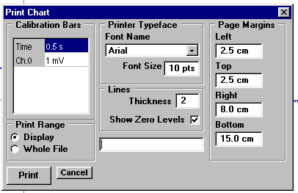
To print the recording on Chart’s display screen, select Print.. from the File menu to open the record printing dialog box.

Calibration bars are added adjacent to the plotted traces indicating the magnitude and units of the signal level for each channel, and time. The bars are initially set to 10% of the displayed range. You can alter the size of these bars by entering new values in the Calibration Bars table. Note that if a bar value is set to zero (or a blank entry), the bar is not displayed.

The size of the printing area on the page can be specified by setting the Page Margins (Left, Right Top, Bottom).

The type face and size of the text used to label the plot can be selected using Font Name list and Font Size box.

The Line Thickness box sets the thickness of the lines used to draw the traces.

The Show Zero Levels check box determines whether the signal zero levels are indicated by horizontal dotted lines (on by default).

Select Display to print out the part of the recording currently displayed in the chart window on the screen. Select Whole File to print out the complete recording stored in the file on a series of pages.

Once the desired settings have been made, click OK to output the recording to the printer.

Choosing and setting up printers
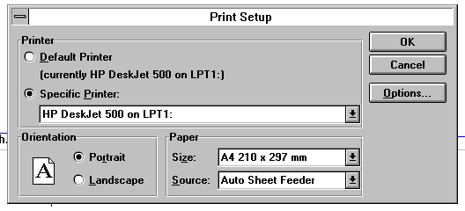
Select Print setup.. from the File menu to select the printer to be used and to change the size and orientation of the printed page.

Orientation: Portrait vs. Landscape. In Portrait orientation the traces are printed upright as is normal on a page of text. In Landscape mode the printed records are rotated 90 degrees before being printed on the page.

Paper Size and Source. Indicates the type of paper in the selected printer and means by which it is being fed into the printer. Note that the options available here depend on the type of printer, its features, and the size of paper loaded into it. WARNING: If these settings do not match the actual paper size and configuration of the printer unpredictable results may occur when printing.

Options. Clicking the Options button allows to you change details aspects of the operation of your printer. Changing these from their default settings may have unpredictable results. Consult the documentation with your printer if you need to make changes.

Using the stimulus generator

Chart’s built-in stimulus pulse generator can be used to a output a series of 5V stimulus voltage pulses via the STIM OUT output on the Intracept TSI1 I/O box while recording is in progress. These pulses can be used to trigger the Intracept TSS10 physiological stimulator (or any device which accepts at TTL trigger input).

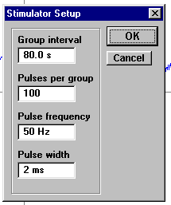
Setting up the stimulator
Select Stimulator.. from the Setup menu to set up Chart’s stimulus pulse generator.

Stimulus pulses (5V amplitude) are produced in groups at predefined intervals, as defined by the following four parameters.

Group interval The time (secs.) between successive groups of stimulus pulses.

Pulses per group The number of stimulus pulses contained within a group.

Pulse frequency The frequency (Hz) at which the stimuli are produced within a group (assuming more than one stimulus pulse per group has been requested. (Max. = 100 Hz)

Pulse width The duration of each stimulus pulse (ms). (Min. = 1 ms)

Using the stimulator
The stimulus generator is turned on and off by clicking on the Stimulus On / Off button while recording is in progress.

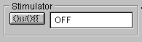

Computing heart rate from an electrocardiogram

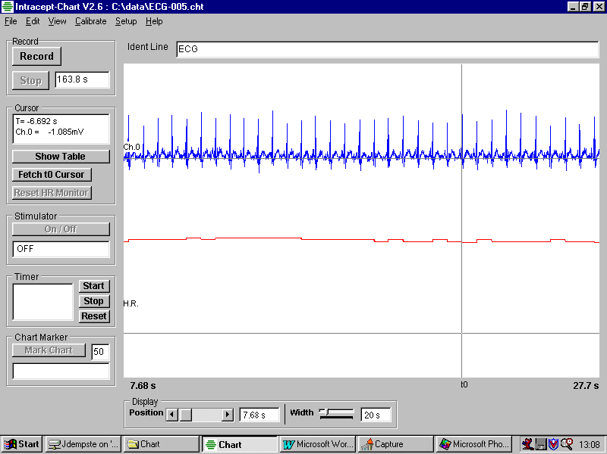
Chart’s heart rate processor computes the beat-by-beat heart rate from an electrocardiogram (ECG) signal in real time and stores it in another channel along with the ECG.

To enable heart rate processing.

- Configure Chart to have two inputs channels - one will be used to record the ECG, the other to store the heart rate.

- Make the appropriate connections to record an ECG signal on input ADC0. Set the units of Ch.0 to “mV” and the appropriate amplifier gain factors in the channel settings table as used by your amplifier.
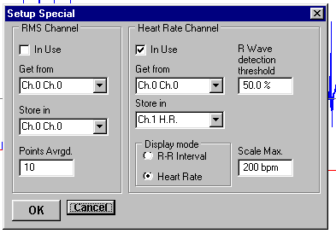
- Select Computed channels.. from the Setup menu to configure heart rate processing.

- Select Ch.0 as the Get From Channel and Ch.1 as the Store In channel.

- The largest component of the ECG waveform is the R-Wave. Chart uses this as a reference point to detect heart beats. Set the R-Wave detection threshold to about 25-50% of the peak amplitude of the R-Wave. (Values should be around 0.5-1.0 mV)

- Set the Max H.R. Scale value to define the upper limit of the computed heart rate range. (Default is 200.).

- Check the In Use box to activate the heart rate function.

Using the electromyogram RMS function

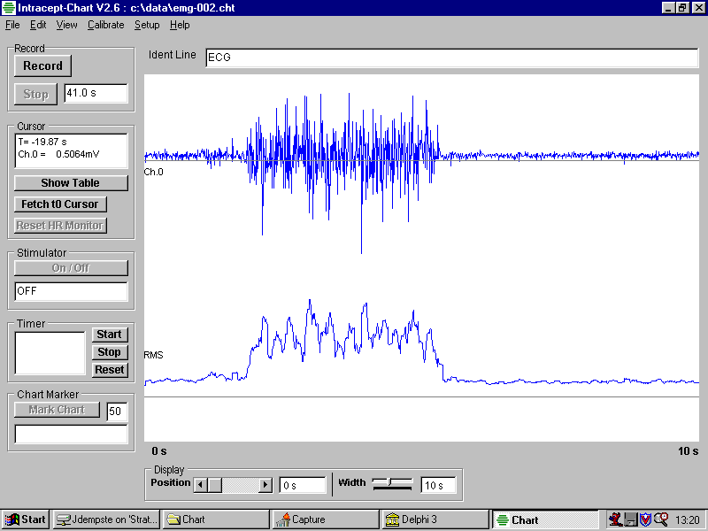
Chart’s RMS function computes the averaged root mean square of an electromyogram (EMG) signal in real time and stores it in another channel. The averaged RMS provides a signal whose amplitude is proportional to the amount of muscular activity.

To enable the RMS function.

- Configure Chart to have two inputs channels - one will be used to record the EMG, the other to store the RMS signal.

- Make the appropriate connections to record an EMG signal on input ADC0. Set the units of Ch.0 to “mV” and the appropriate amplifier gain factors in the channel settings table as used by your amplifier.

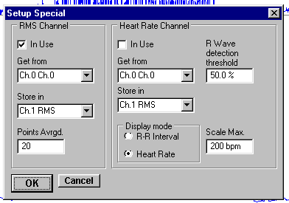
- Select Computed channels.. from the Setup menu to configure the RMS function.

- Select Ch.0 as the Get From Channel and Ch.1 as the Store In channel.

- Set the number of sample points to be used in computing the running average of the RMS signal. The larger the number of points the smoother the signal. (Min. = 10, Max. = 100).

- Check the In Use box to activate the RMS function.

Using a CED 1902 amplifier

Chart supports the use of the Cambridge Electronic Design 1902 programmable amplifier. If you have this amplifier attached to your computer you can control its inputs, gain and filter settings from within Chart. The CED 1902 output should always be attached to input channel ADC0 and may be controlled via either the computer’s COM1 or COM2 serial port.

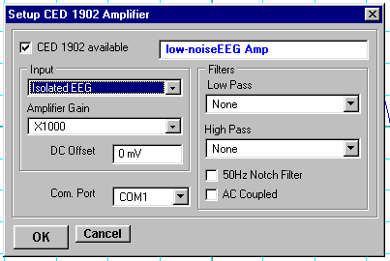
To configure a 1902 amplifier, select CED 1902 Amplifier.. from the Setup menu to open the CED 1902 setup dialog box.

CED 1902 Available

Indicates whether the CED 1902 is in use. If you do not have a CED 1902 attached (or if you do not want to use it) un-tick this box.

Inputs

The CED 1902 has two inputs. The Electrodes input is an electrically isolated differential amplifier input used to record ECG, EMG and similar signals. Isolation makes it safe to attach recording leads to human subjects. The Transducer input is a differential amplifier input used to record from transducers such as force and pressure transducers. It is not isolated.

The following CED 1902 input modes can be selected :

Grounded The input is connected to ground, i.e. there is no signal.
Single Ended The transducer input in singled ended (i.e. non-differential) mode.
Normal Diff. The transducer input in differential amplifier mode.
Inverted Diff. The transducer input in differential mode with the signal inverted.
Grounded EEG The input is connected to ground, i.e. there is no signal.
Isolated EEG The electrically isolated input for ECG/EMG work.

Note. Normal Diff. mode is used when recording from a force or pressure transducer connected to the Transducer input and Isolated EEG used when recording from the Electrodes input. When using non-standard transducer consult your experimental notes and/or the CED 1902 manual.

Amplifier Gain Sets the gain of the CED 1902 amplifier. The range of gain settings depends on which input is in use. When using the Transducer input there are 11 gain settings (X1, X3, X10, X30, X100, X300, X1000, X3000, X10000, X30000, X10000). When using the Electrodes input (X1000, X3000, X10000, X30000, X100000, X300000, X1000000, X3000000, X10000000, X30000000, X10000000).

Note. When the CED 1902 is in use, the gain setting is automatically entered into the Amp. Gain column of Ch.0 in the Channel Settings table.

Low Pass Filter Sets the cut-off frequency of the CED 1902’s built-in low pass filter. The filter can be set to None (out of use), 1000Hz, 500Hz, 100Hz. The low pass filter removes signal frequencies signal higher than the cut-off, smoothing the signal.

High Pass Filter Sets the cut-off frequency of the CED 1902’s built-in high pass filter. The filter can be set to None (out of use), 50Hz, 100Hz, 200Hz. The high pass filter removes signal frequencies signal lower than the cut-off, removing steady and slowly changed components of the signal.

AC Coupled Tick this box to make the CED 1902 input AC (alternating current) coupled. In this mode only variations in the signal are allowed through to the amplifier, constant (DC) levels are blocked. (AC coupling should be used with EMG and ECG recordings but not with force or pressure transducer recordings.)

50 Hz Filter Tick this box to activate the notch filter which selectively removes frequencies around 50Hz. (Used to remove 50Hz interference from mains power lines).

DC Offset The DC Offset facility adds or subtracts a DC voltage level from the input. The offset range depends upon the input mode (Normal Diff+ and Inverted Diff- = +/-0.5mV, Single Ended =+/-500mV, Isolated EEG = +/-0.1mV). The offset facility is often used to cancel out the standing DC voltage signal from tension transducers.

COM Port The serial communications port to used to control the CED 1902. Can be set to either COM1 or COM2.

